How to setup SOAP UI for CI/CD

1. Setup SOAP UI
   1. Download and Install SOAP UI Open Source version
   2. Setup SOAPUI_HOME environment Variable and update path as follows

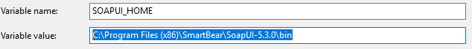



1. Create Test Case in SOAP UI
   1. Create SOAP/REST Test case in SOAP UI

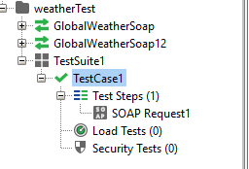

* 1. Run the test case manually to verify its working
  2. Once the test case is successfully executed, save the project in xml format(Project->save Project As->*.xml)

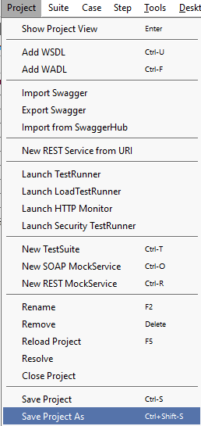

1. Setup Maven
   1. Install Maven and setup Maven Home
   2. Make sure that Maven commands are working properly from command prompt
2. Create Maven Project
   1. In Eclipse, create a new Maven Project and use the attached pom file



* 1. In the pom file make the following changes as applicable to your project
     1. Change the project file path and host as applicable



* + 1. Change the repository to CUN Nexus repository

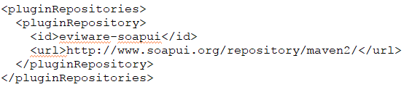

* + 1. Change Test Suite name and Test Case name as applicable



* + 1. Update Maven Project

1. Run Maven Test
   1. You can run the maven test as (Run->Run as Configuration)

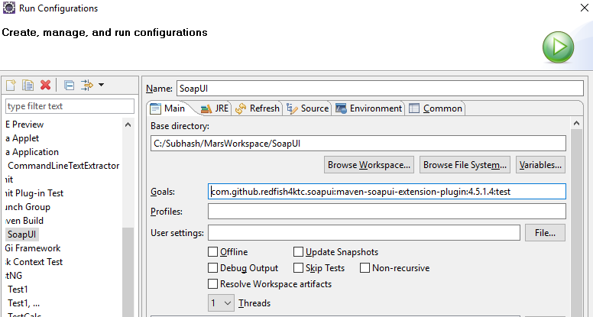

* 1. Or open the command prompt and type the Goals(From above screenshot) and it should trigger the test case

1. Reports
   1. By default, the following reports are generated in target\soapui reports in the project folder

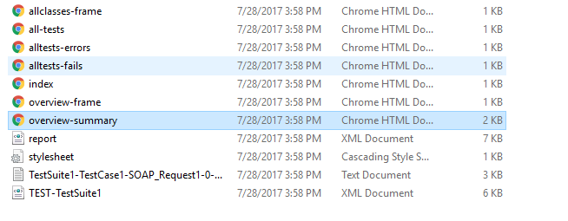

* 1. Overview-summary report is as follows:

